Histogram Equalization
Code:
import cv2
import numpy as np

image = cv2.imread('tekne.jpg', cv2.IMREAD_GRAYSCALE)
image = cv2.resize(image, (800, 600))
equalized_image = cv2.equalizeHist(image)

cv2.imshow('Original Image', image)
cv2.imshow('Histogram Equalized Image', equalized_image)

cv2.waitKey(0)
cv2.destroyAllWindows()
Code Explanation:
- Import Libraries:
  - cv2: OpenCV library for image processing.
  - numpy: Used for numerical operations but isn't utilized directly in this script.
- Read Image:
  - cv2.imread('tekne.jpg', cv2.IMREAD_GRAYSCALE) reads the input image in grayscale mode.
- Resize Image:
  - cv2.resize(image, (800, 600)) reduces the image dimensions to 800x600 pixels, ensuring it is not too large for display or processing.
- Histogram Equalization:
  - cv2.equalizeHist(image) enhances the contrast of the grayscale image by redistributing pixel intensity values.
- Display Images:
  - cv2.imshow opens a window to display the original and histogram-equalized images.
- Wait for Key Press:
  - cv2.waitKey(0) keeps the display windows open until a key is pressed.
- Close Windows:
  - cv2.destroyAllWindows() ensures all OpenCV windows are closed.
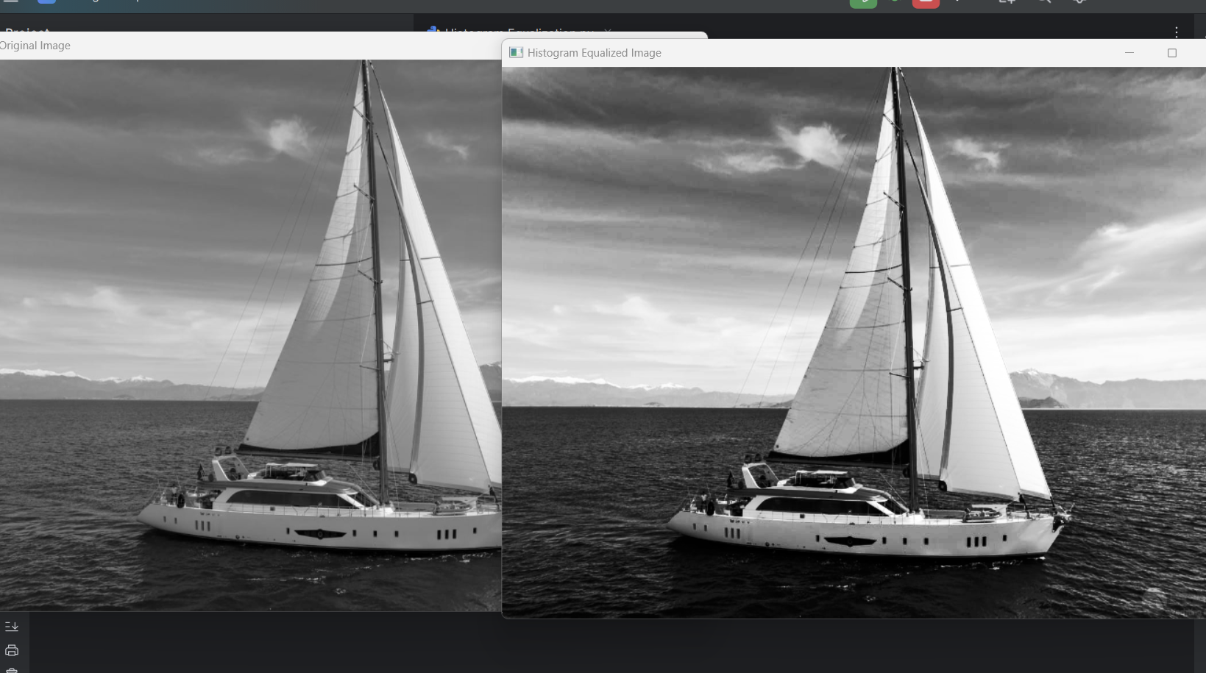
code output:

Report
Purpose
Histogram equalization is used to enhance image contrast by spreading out the intensity distribution across all available levels. This is especially useful for images that appear too dark or too bright.
Input Image
The input image (tekne.jpg) is converted to grayscale and resized to 800x600 pixels to optimize processing and display.
Process
- The input image is processed with the cv2.equalizeHist function.
- This function adjusts the pixel intensity distribution such that the histogram becomes more uniform, improving the visibility of details.
Output
- Original Image: The grayscale version of the input image with its original contrast.
- Equalized Image: A version of the input image with enhanced contrast.
Observations
Histogram equalization can:
- Highlight hidden details in darker or lighter regions.
- Improve the visual appeal of the image.
- Be unsuitable for images that already have balanced contrast, as it might introduce artifacts.

